Worksheet on Control and Coordination
Module – 01
I.Choose the correct answer
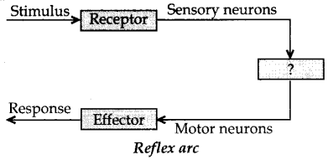
1.Give the missing term.
(a) Spinal cord
(b) Brain
(c) Cranial nerves
(d) Relay nerve
2. 12. A microscopic gap between a pair of adjacent neurons over which nerve impulses pass is called
(a) neurotransmitter
(b) dendrites
(c) axon
(d) synapse
3. 17. Breathing is controlled by which part of the brain?
a) Cerebrum
(b) Cerebellum
(c) Hypothalamus
(d) Medulla oblongata
4. Which part of nervous system controls the reflex activities of the body?
(a) Brain
(b) Spinal cord
(c) Cerebrum
(d) Cerebellum

5. The highest coordinating centre in the human body is
(a) spinal cord
(b) heart
(c) brain
(d) kidney
II. Answer the following questions :
1.What are receptors ? What do we call the receptors present in our nose?
2.What is reflex action ? Explain with example .
3. What is a nerve impulse ?
4.Describe the structure of human brain with diagram.
5.What is neuromuscular junction ?
6.Draw the structure of a neuron .
7. Draw the reflex arc.
8. Describe the function of cerebellum.
9. What is a synapse ?
10. How is the brain protected in our body ?

